Lab Task 4: Write a program to convert following code into assembly program.

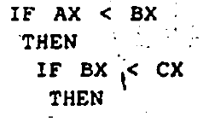

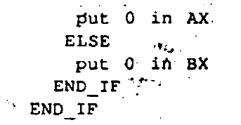

org 100h

mov ax, 33h

mov bx, 35h

mov cx, 37h

cmp ax, bx

jl if

mov dl, 30h

mov ah, 2

int 21h

jmp exit

if:

cmp bx, cx

mov dl, 31h

mov ah, 2

int 21h

jmp exit

exit:

mov ah, 4ch

int 21h

ret

Lab task 5: Write a program to convert following code into assembly program.

